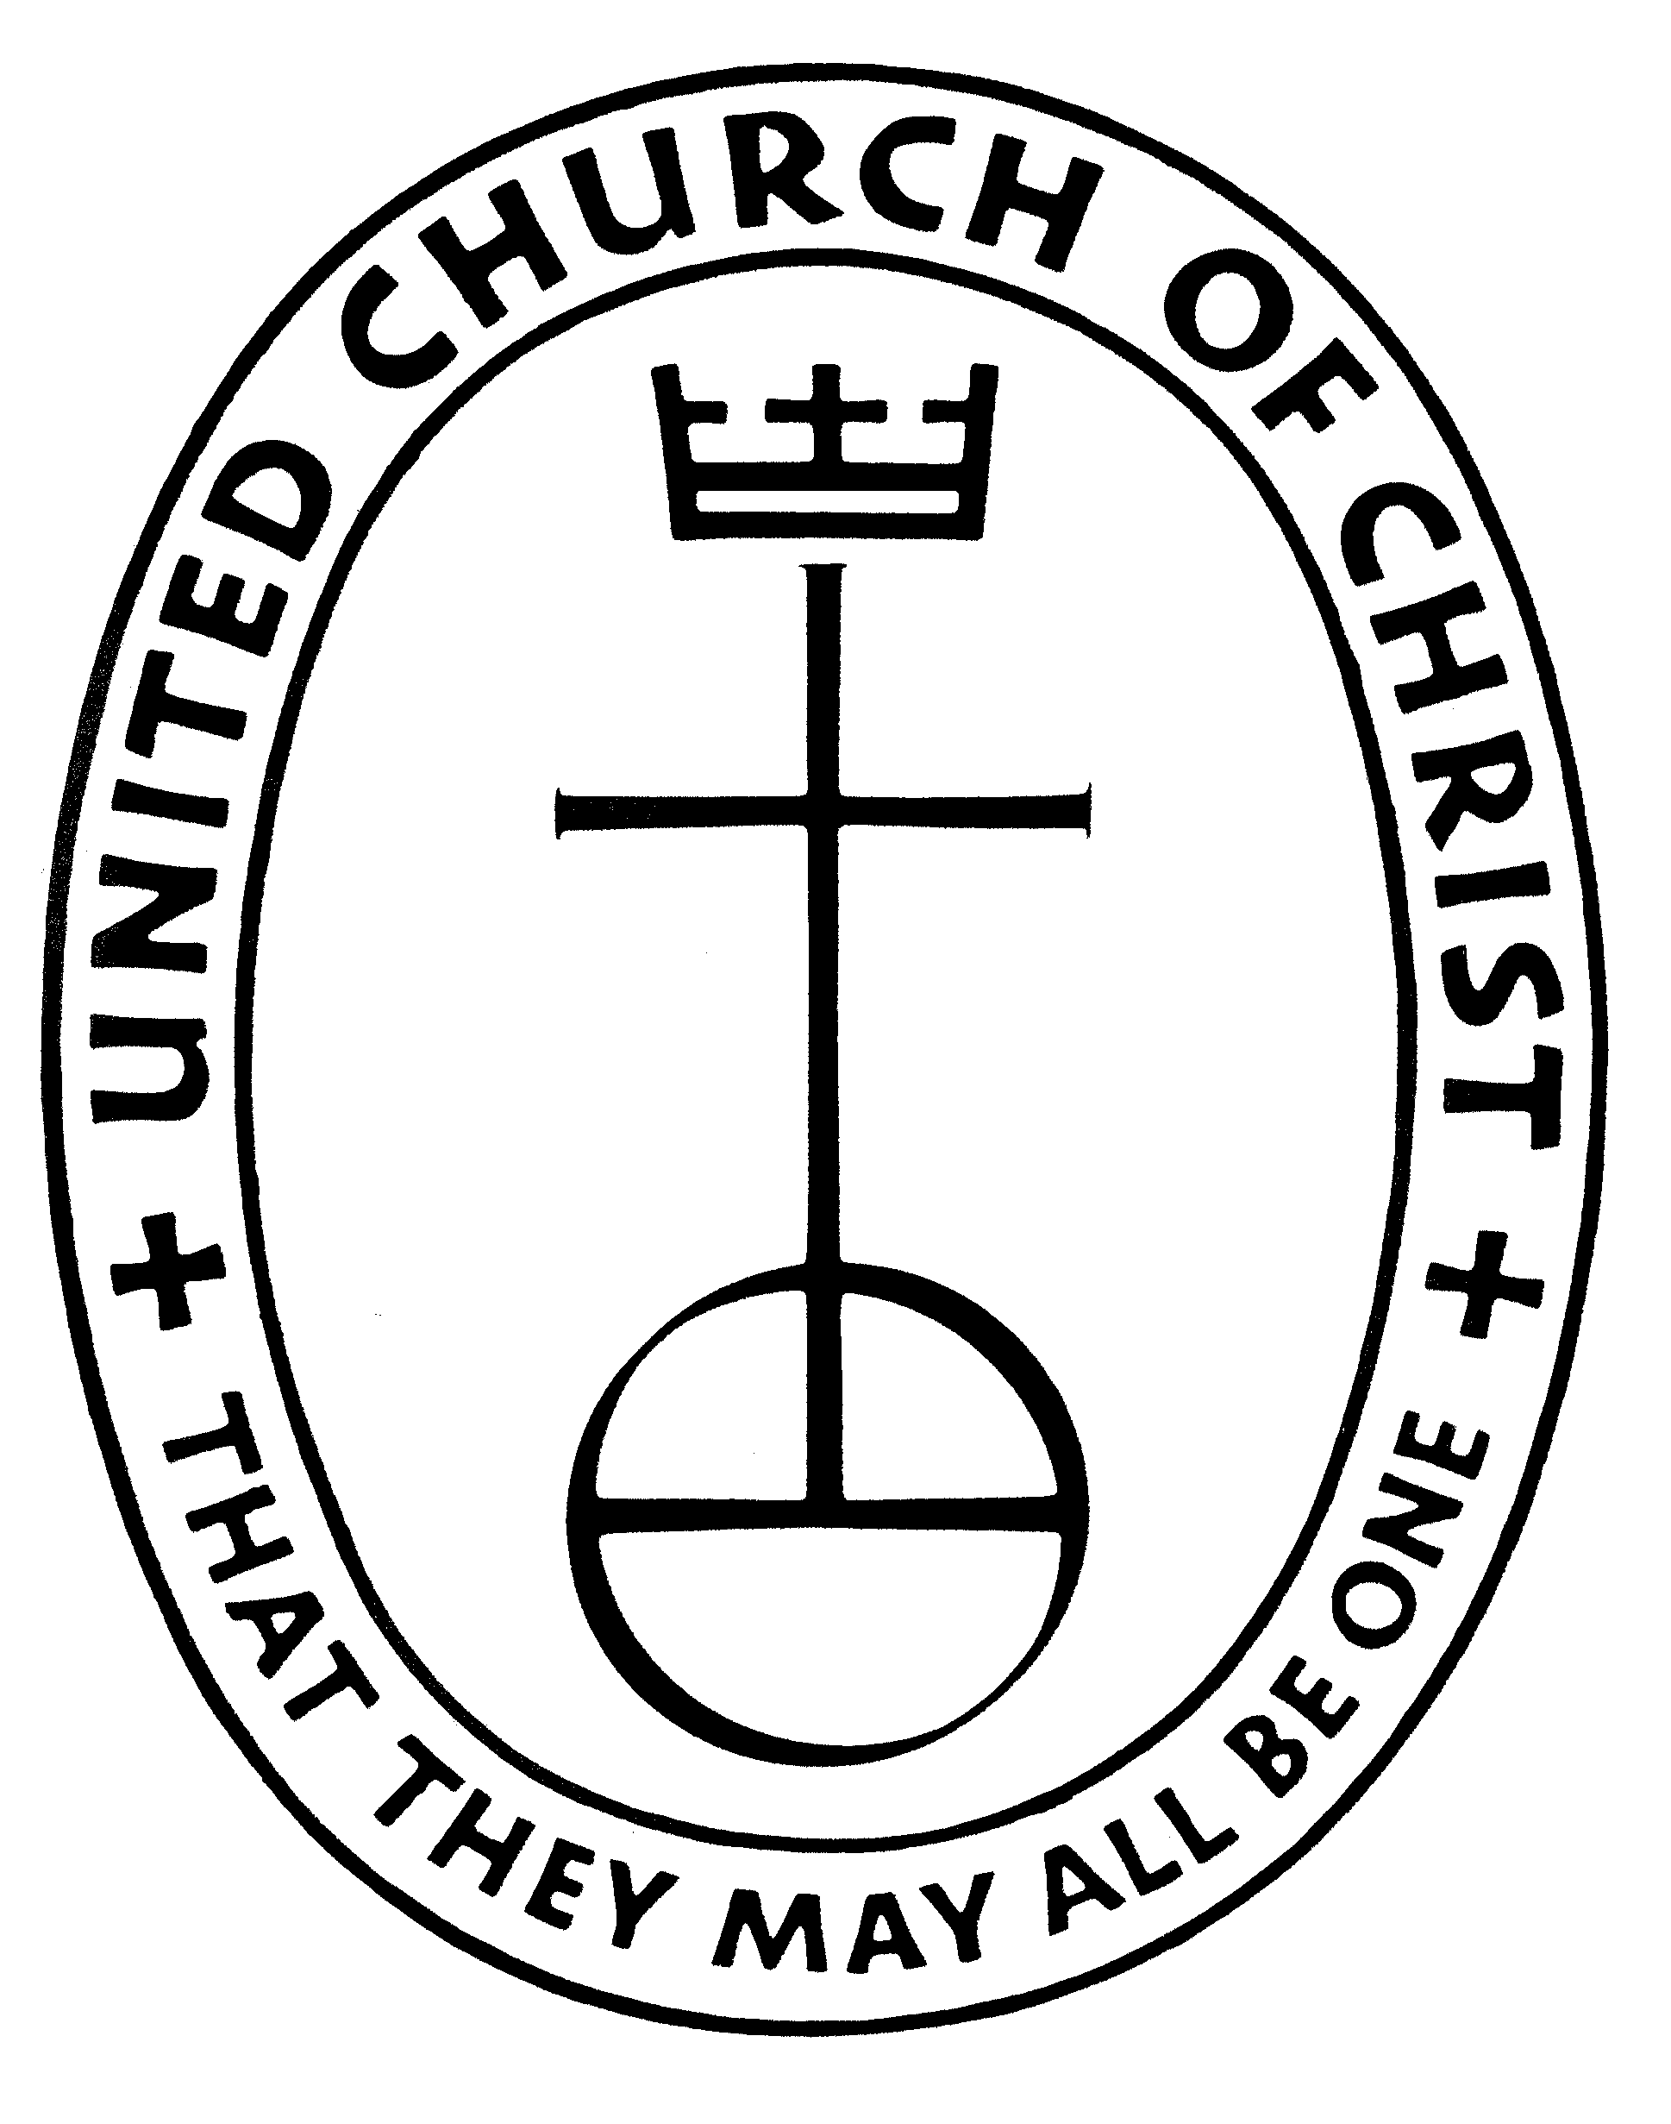Southern Association
Southern California Nevada Conference
United Church of Christ
4070 Jackdaw Street

San Diego, CA 92103-1729
(619) 296-9063
E-mail: southernassociation@sascncucc.com

Exempt Standing
The following is from the working group which is rewriting the Manual on Ministry.
“The rite of ordination is understood as lifelong, however there may come occasions when the public ministry of an Ordained Minister comes to a close. The United Church of Christ is proposing the there be a new category of retired standing called “Exempt Standing” intended to signify that an Ordained Minister wishes to remain on the Associations’ roster but covenants to no longer perform public ministry. Their Committee on Ministry then covenants to release the minister from ongoing requirements to maintain standing, such as continuing education and boundary awareness training. Ministers with Exempt Standing can continue to vote in the Association where Exempt Standing is held and may co-officiate the Sacraments at the invitation of an active Ordained Minister in good standing. Exempt Standing does not end the relationship of support and accountability. Those who hold Exempt Standing continue to be responsible for faithfully embodying the UCC Ministerial Code and can be the subject of Fitness Reviews. Committees are responsible to maintain annual contact with ministers holding Exempt Standing, in order to keep accurate contact information and to communicate relevant information from the Committee on Ministry.”
Here in the Southern Association we are going to use the idea of Exempt standing as presented below:
The nature of covenant implies mutual accountability and grace so it is recognized that under special circumstances an Exempt minister may occasionally make a request of the Church and Ministry Committee for the privilege of co-officiating at a wedding or funeral at the invitation of an active Ordained Minister in good standing. (For example, such an occasion might be on behalf of a family member or relative). Occasional Guest preaching would also be an option but any kind of on-going or regular pulpit supply would require reactivating Regular Standing which would also require current Boundary Training and Continuing Education Units.
The form entitled “Exempt Standing Request” is being provided to all retired ministers. If you fit the criteria for Exempt standing and would like to be changed to this category, please fill out the form and return it to the Association office, either by email or regular mail. With Exempt standing you will be exempt from both Boundary Awareness Training and Continuing Education Units. Pastors who have already been granted a Boundary Awareness Training waiver will be automatically be changed to Exempt standing.

Southern Association
Southern California Nevada Conference
United Church of Christ
4070 Jackdaw Street

San Diego, CA 92103-1729
(619) 296-9063
E-mail: southernassociation@sascncucc.com

Exempt Standing Request

Retired Clergy. If you are no longer active in ministry in any setting and you would like to obtain Exempt standing, please fill out the following information, sign the form at the bottom, and mail it to the Association Office, or return it by email to southernassociation@sascncucc.com.

I wish my United Church of Christ standing to be listed as Exempt
(check all those that apply):
_____ I am no longer in active ministry.
_____ I am no longer preaching on a supply basis.
_____ I am not involved in an interim-ministry setting.
_____ I am not involved in a ministry of visitation or membership development for a congregation.
_____ I am not officiating at weddings or funerals.

Name: ______________________________________ Date: ___________________

Signature: ___________________________________

Please mail to: Southern Association
United Church of Christ
4070 Jackdaw St.
San Diego, CA 92103

-or-

Email to: southernassociation@sascncucc.com

